Effect of Monoethanolamine on the Structural, Optical, and Photocatalytic Properties of Sol–Gel Derived CuSnO3 for Methyl Orange Degradation
Hari Sanjaya [a, b]*, Hermansyah Aziz [b], Yeni Stiadi [b], Syukri Arief [b], Septian Budiman [c, d], and Yohandri [e]
[a] Department of Chemistry, Universitas Negeri Padang, Jln. Hamka, Padang, 25132, Indonesia
[b] Department of Chemistry, Andalas University, Jln. Limau Manis, Kec. Pauh, Padang, 25175, Indonesia
[c] Nanoscience and Technology, Chulalongkorn University, 254 Phaya Thai Rd, Wang Mai, Pathum Wan, Bangkok, 10330, Thailand 09/04/2026, 13/06/2026, 11/07/2026
[d] Metallurgy and Materials Science Research Institute, Chulalongkorn University, 254 Phyathai Road, Pathum Wan, Bangkok, 10330, Thailand
[e] Department of Physics, Universitas Negeri Padang, Jln. Hamka, Padang, 25132, Indonesia.
* Author for correspondence; e-mail: harysanjaya.unp@yahoo.com
ORCiD: https://orcid.org/0000-0002-1207-3763
Received: 9 April 2026 Revised: 13 June 2026 Accepted: 11 July 2026 Published: 2026
Citation: Sanjaya H., Aziz H., Stiadi Y., Arief S., Budiman S., and Yohandri, Effect of monoethanolamine on the structural, optical, and photocatalytic properties of sol–gel derived CuSnO₃ for methyl orange degradation. Chiang Mai Journal of Science, 2026; 53(x): e202600X. DOI 10.12982/CMJS.2026.00X.
Copyright: ©2026 Author (s). This is an Open Access article distributed under the term of the Creative Commons Attribution 4.0 International License CC BY 4.0 (https://creativecommons.org/licenses/by/4.0).
GRAPHICAL ABSTRACT

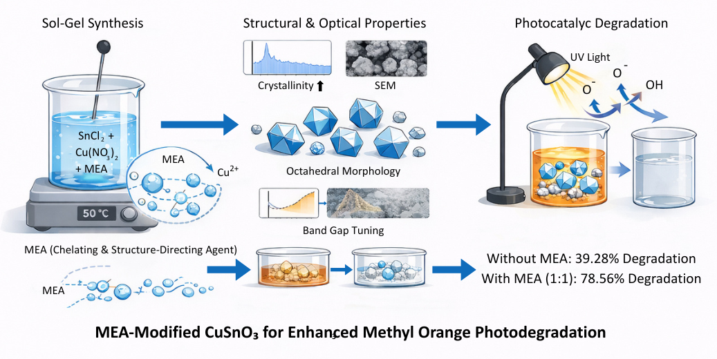

ABSTRACT
This study investigates the degradation of Methyl Orange (MO) using CuSnO₃ (CSO) modified with monoethanolamine (MEA) as a chelating and structure-directing additive and synthesized by the sol–gel method. The effects of MEA concentration on the structural, morphological, optical, and photocatalytic properties of CSO were systematically examined. X-ray diffraction (XRD) confirmed that all samples exhibited the cubic spinel CuSnO₃ phase, and MEA enhanced crystallinity and improved structural order. Scanning electron microscopy (SEM) showed that MEA altered particle morphology from irregular, strongly agglomerated grains to more uniform spherical and octahedral structures. Ultraviolet diffuse reflectance spectroscopy (UV–DRS) and Tauc plot analysis indicated optical band gap values of 2.4, 3.13, 2.79, and 2.65 eV for the unmodified, 1:1, 1:2, and 2:1 MEA samples, respectively. Fourier transform infrared spectroscopy (FTIR) confirmed the formation of the metal–oxygen oxide framework. Photocatalytic degradation of MO showed that the unmodified CSO achieved only 39.28% degradation (k_{app} = 0.0059 min⁻¹), whereas the 1:1 MEA-modified CSO achieved 78.56% degradation (k_{app} = 0.0124 min⁻¹). Pseudo-first-order kinetics was confirmed for all samples. These results demonstrate that MEA acts as an effective structure-directing and chelating agent that enables precise control over the physicochemical properties of CuSnO₃ and substantially enhances its photocatalytic performance.

Keywords: CuSnO₃, methyl orange, monoethanolamine, photocatalytic degradation, sol–gel synthesis

HIGHLIGHTS
- MEA improved the crystallinity of sol–gel-derived CuSnO₃.
- The 1:1 MEA ratio produced well-defined octahedral particles with reduced agglomeration.
- Optical band gap varied with MEA content: 2.4 eV (unmodified) to 3.13 eV (1:1 MEA).
- CuSnO₃ with 1:1 MEA achieved 78.56% MO degradation (k_{app} = 0.0124 min⁻¹).
- MEA acted as an effective chelating and structure-directing agent during precursor formation.

1. INTRODUCTION
Synthetic dyes are widely employed in the textile, paint, leather, paper, pharmaceutical, and food industries because of their strong color intensity, versatility, and stability under processing conditions. However, their large-scale production and widespread use have led to a substantial increase in the discharge of dye-laden wastewater into aquatic environments [1]. Once released, many synthetic dyes persist in water bodies because of their high chemical stability, complex aromatic structures, and resistance to biodegradation, making their removal from wastewater a persistent environmental challenge.
Methyl Orange (MO) is a commonly used synthetic azo dye that exhibits carcinogenic, mutagenic, and toxic properties. Exposure to MO-contaminated wastewater may cause irritation of the skin and eyes, as well as respiratory and digestive disorders. In aquatic systems, MO can reduce water quality by decreasing light penetration and dissolved oxygen concentration, thereby disrupting photosynthetic activity and the survival of aquatic organisms [2]. Photocatalysis is an advanced oxidation process in which semiconductor materials absorb light and generate electron–hole pairs that produce highly reactive species such as hydroxyl radicals and superoxide ions [3]. These species can oxidize complex dye molecules into less harmful intermediates or fully mineralized products [4].
Among semiconductor photocatalysts, ZnO has attracted considerable attention because of its chemical stability and UV photocatalytic activity; however, its wide band gap (~3.37 eV) restricts light absorption and rapid recombination of electron–hole pairs reduces efficiency [5]. A comprehensive review on ZnO/TiO₂-based photocatalysts emphasized that precursor chemistry, crystal size, and surface engineering are decisive for photodegradation performance [6]. These limitations have encouraged the investigation of alternative semiconductors.
CuSnO₃ (CSO) is an oxide semiconductor with a reported band gap in the range of 2.0–2.5 eV, composed of earth-abundant, non-toxic, and thermally stable elements [7]. Earlier studies have established important benchmarks for CuSnO₃. Singh et al. reported the structural and optical characterization of CuSnO₃ prepared by a ceramic route, providing fundamental physicochemical reference data [8]. Abolhasani et al. demonstrated that sonochemically synthesized CuSnO₃ nanoparticles are effective photocatalysts for methylene blue degradation and environmental remediation [9]. These pioneering works confirm the potential of CuSnO₃ while highlighting that systematic control of morphology, crystallinity, and synthesis conditions in sol–gel systems remains insufficiently explored.
Among synthesis routes, the sol–gel method offers distinct advantages over competing approaches such as hydrothermal synthesis and ball milling: it operates at relatively low temperatures, provides homogeneous mixing at the molecular level, enables precise control over composition and particle morphology, and avoids the high-pressure equipment required by hydrothermal routes [10]. Ball milling can introduce contamination and produces broad particle-size distributions. These considerations justify the selection of sol–gel synthesis for the present work.
Monoethanolamine (MEA) is a promising additive for sol–gel synthesis that functions as a complexing agent, regulates nucleation and crystal growth, and suppresses particle agglomeration [11]. Gómez-Núñez et al. showed that ethanolamine coordinates metal ions in sol–gel ZnO inks, stabilizing the precursor network and delaying premature precipitation [12]. Tumbul confirmed that MEA content directly controls the crystallinity of ZnO thin films, establishing MEA as a structural control parameter rather than merely a solvent aid [13]. These mechanistic insights support using MEA in the present CuSnO₃ synthesis.
Florence reported that Citrus limetta-mediated ZnO nanopellets enhance photocatalytic dye degradation, highlighting the potential of morphology-controlled oxide nanomaterials [14]. Phatai et al. demonstrated that ultrasonic-assisted sol–gel synthesis tunes phase formation of zinc–silver doped hydroxyapatite [15]. Xu et al. reported that Cu₂O(ClO₄)₂/TiO₂ dandelion-shaped nanospheres exhibit combined photocatalytic functions, emphasizing the importance of structural design [16].
The novelty of the present work lies in the systematic use of MEA not merely as a stabilizing solvent but as a controllable chelating and structure-directing agent in the sol–gel synthesis of CuSnO₃. By varying the MEA-to-metal precursor molar ratio (1:1, 1:2, and 2:1), this study establishes for the first time a direct quantitative correlation between additive concentration, crystallinity, particle morphology, optical band gap, and methyl orange photocatalytic degradation efficiency — providing mechanistic insight into MEA's role during precursor complexation, nucleation, and crystal growth.
The study aims to synthesize CuSnO₃ by the sol–gel method and examine the effect of MEA concentration on the structural, morphological, optical, and photocatalytic properties of the resulting materials. Samples were characterized by XRD, SEM, UV–DRS, X-ray fluorescence (XRF), and FTIR spectroscopy.

2. MATERIALS AND METHODS
2.1 Materials
All chemicals were of analytical grade and obtained from Merck. Tin(II) chloride (SnCl₂) and copper(II) nitrate (Cu(NO₃)₂) were used as metal precursors for CuSnO₃ synthesis. Monoethanolamine (MEA) was employed as the chelating and structure-directing additive. Isopropanol and glacial acetic acid served as solvents. All reagents were used as received without further purification [17].

2.2 Synthesis Procedure
CuSnO₃ (CSO) was prepared through a sol–gel powder synthesis route. In the standard synthesis, 0.7584 g of SnCl₂ and 0.7504 g of Cu(NO₃)₂ were dissolved in isopropanol to form a clear precursor solution. The mixture was ultrasonicated for 1 h, followed by magnetic stirring at 50 °C for 12 h to promote hydrolysis and condensation. The resulting gel was dried at 50 °C for 12 h to yield a xerogel precursor [18].
Based on TGA of the xerogel, three calcination temperatures were selected: 400 °C, 600 °C, and 800 °C; each sample was calcined for 2 h under atmospheric conditions. MEA was introduced at molar ratios of 1:1, 1:2, and 2:1 relative to the total metal precursors. After MEA addition, solutions were ultrasonicated for 1 h and stirred at 50 °C for 12 h. Gels were calcined at the optimum temperature of 600 °C for 2 h [19]. A reference sample was prepared without additive under identical conditions.

2.3 Photocatalytic Experiments
Photocatalytic experiments were conducted using MO as the model pollutant under the following conditions: initial MO concentration, 10 mg/L; catalyst loading, 50 mg per 100 mL; solution pH, ~6.8 (neutral); reaction volume, 100 mL. Prior to irradiation, the suspension was stirred in the dark for 30 min to establish adsorption–desorption equilibrium. Irradiation was performed using a UV lamp (365 nm, 8 W; light intensity ~1.2 mW/cm²). Aliquots of 3 mL were withdrawn at predetermined intervals, filtered through 0.45 μm membrane filters, and analyzed by UV–Vis spectrophotometry at λ_{max} = 464 nm. Degradation efficiency was calculated as:

$$\text{Degradation (\%)}=\left(\frac{C_{0}-C}{C_{0}}\right)×100$$

where C₀ is the initial MO concentration and C is the concentration at irradiation time t. Pseudo-first-order kinetics was applied: ln(C/C₀) = −k_{app}t, where k_{app} is the apparent pseudo-first-order rate constant (min⁻¹). Control experiments included: (1) photolysis alone (irradiation without catalyst); (2) dark adsorption (catalyst without light); and (3) a blank test (neither catalyst nor light). Each experiment was conducted in triplicate and results are reported as mean values.

2.4 Characterization
Phase composition and crystallinity were analyzed by XRD with peak indexing referenced against JCPDS card No. 00-021-1250 for CuSnO₃. Surface morphology was examined by SEM. Optical properties were investigated by UV–DRS; the Kubelka–Munk function and Tauc plots (direct-allowed transition, n = 1/2, i.e., (αhν)² vs. hν) were used to estimate optical band gap energy [20]. Elemental composition was examined by XRF. Functional groups and metal–oxygen bonding were identified by FTIR, with particular attention to the fingerprint region below 600 cm⁻¹.

3. RESULTS AND DISCUSSION
3.1 Formation of CuSnO₃ through the Sol–Gel Route
The sol–gel approach provided an effective route for synthesizing CuSnO₃ with good compositional homogeneity. Stirring at 50 °C for 12 h promoted hydrolysis and condensation, gradually transforming the solution into a stable sol and then a gel [21]. After drying at 50 °C for 12 h, a solid xerogel with a distinct turquoise color was obtained, characteristic of copper-containing oxide precursors [22]. The uniform precursor distribution established at this stage directly affects phase development and crystallinity after heat treatment.

3.2 Phase Identification and Crystallinity (XRD)
The XRD patterns (Figure 1) confirm the formation of the CuSnO₃ cubic spinel phase in all samples, consistent with JCPDS card No. 00-021-1250. All major diffraction peaks are indexed accordingly. Minor peaks at approximately 35.5° and 38.7° 2θ observed in the unmodified sample are consistent with trace CuO (JCPDS 45-0937); these peaks diminish in MEA-modified samples, indicating that MEA promotes phase purity. No distinct SnO₂ peaks were identified, confirming effective incorporation of Sn into the spinel lattice.

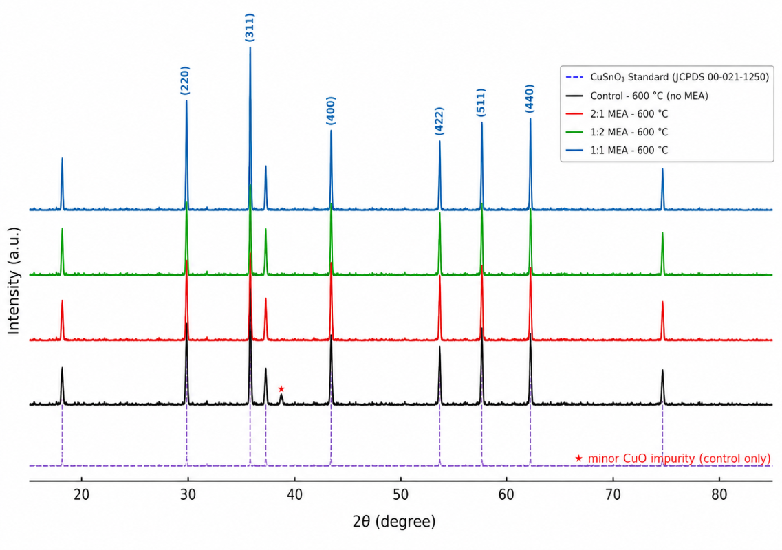

Figure 1. XRD patterns of CuSnO₃ synthesized with various MEA concentrations, all calcined at 600 °C. The CuSnO₃ standard (JCPDS 00-021-1250) is shown at the bottom for comparison. Colored markers indicate indexed peaks. (*) minor CuO impurity peaks in the unmodified sample.

The MEA-modified samples exhibited sharper and more intense diffraction peaks than the unmodified sample, confirming improved crystallinity. The 1:1 sample displayed the narrowest peak widths and highest intensities, implying larger coherent crystalline domains and better structural ordering. The 1:2 and 2:1 samples showed somewhat reduced peak intensity and slight broadening, indicating a decline in crystallinity when MEA content deviated from the optimum. These XRD results are consistent with previously reported CuSnO₃ diffractograms [8, 9] and confirm that MEA acts as a structure-directing agent during nucleation and crystal growth.

3.3 Particle Morphology (SEM)
The SEM micrographs (Figure 2) reveal the influence of MEA on particle morphology. The unmodified sample (Figure 2a) exhibited irregularly shaped particles with pronounced agglomeration and large grain sizes, typical of sol–gel-derived oxides synthesized without chelating control [23].

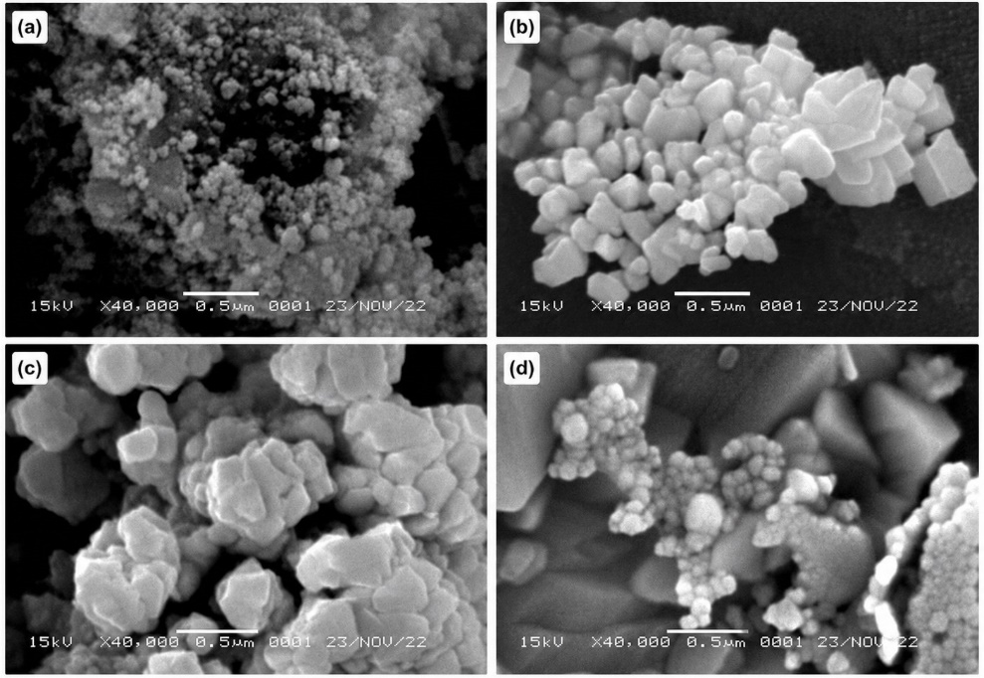

Figure 2. SEM micrographs of CuSnO₃ synthesized (a) without additive, (b) with 1:1 MEA, (c) with 1:2 MEA, and (d) with 2:1 MEA, all calcined at 600 °C. Scale bar: 500 nm. Accelerating voltage: 15 kV; magnification: ×40,000.

The 1:1 MEA sample (Figure 2b) showed well-defined octahedral particles with a narrower size distribution and substantially reduced agglomeration. MEA's amino (–NH₂) and hydroxyl (–OH) functional groups coordinate with Cu²⁺ and Sn⁴⁺ ions during precursor formation, moderating hydrolysis and condensation rates and enabling more ordered crystal growth [12]. The formation of octahedral particles reflects a more ordered crystal growth pathway and may expose reactive facets that improve surface interactions during photocatalysis.
The 1:2 and 2:1 samples showed less optimal morphologies with partial agglomeration. Both insufficient and excessive MEA disturb the nucleation–growth balance: too little additive cannot prevent aggregation, while too much may leave residual organics or cause coordination crowding that interferes with crystallization.

3.4 Thermal Behavior and Calcination Temperature Selection (TGA)
The TGA profile (Figure 3) indicates continuous mass loss over 30–800 °C. The first mass-loss region (30–200 °C) is attributed to removal of physically adsorbed water and residual solvent. A more pronounced mass-loss event (200–400 °C) corresponds to decomposition of organic residues; the endothermic feature near 250 °C confirms combustion of these residues [24]. Beyond 400 °C, the TGA curve became nearly stable, indicating that the Cu–Sn–O framework had reached thermal stability.

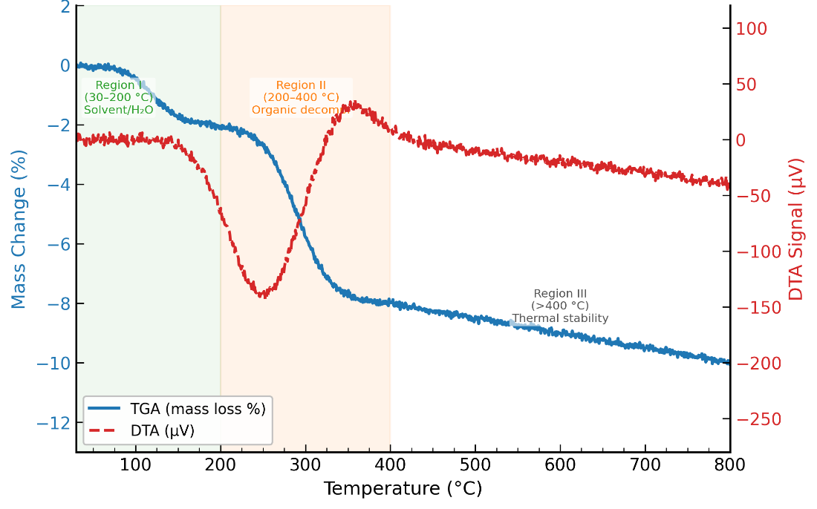

Figure 3. TGA/DTA profile of the CuSnO₃ xerogel precursor recorded from 30 to 800 °C at 10 °C/min under N₂. Left axis: mass loss (%); right axis: DTA signal (μV). Region 30–200 °C: solvent/water removal; region 200–400 °C: organic decomposition.

The observed thermal behavior supports the selection of 400 °C, 600 °C, and 800 °C as calcination temperatures. Among these, 600 °C was identified as most suitable because it provides sufficient thermal energy to remove residual organics and promote crystallization while avoiding excessive grain coarsening [25]. Therefore, 600 °C was used for all MEA-modified sample preparations.

3.5 Elemental Composition and Functional Group Analysis (XRF and FTIR)
The elemental composition and FTIR fingerprint data are summarized in Table 1. Cu and Sn are the dominant elements across all samples, confirming the formation of CuSnO₃. Minor P, Cl, and Ca are attributed to residual precursor species at low concentrations unlikely to alter material behavior significantly.

Table 1. Elemental composition (XRF, wt%), FTIR fingerprint peak position, and optical band gap (Eg) of CuSnO₃ samples with different MEA ratios, all calcined at 600 °C.
Sample | P (%) | Cl (%) | Ca (%) | Cu (%) | Sn (%) | Fingerprint (cm⁻¹) | Eg (eV)
600 °C (no MEA) | 0.983 | 0.063 | 0.292 | 30.457 | 67.817 | 541.82 | 2.4
1:1 MEA (600 °C) | 0.759 | 0.051 | 0 | 32.774 | 66.165 | 523.23 | 3.13
1:2 MEA (600 °C) | 0.756 | 0.036 | 0.097 | 30.112 | 68.706 | 529.56 | 2.79
2:1 MEA (600 °C) | 0.656 | 0.033 | 0 | 28.850 | 69.333 | 535.69 | 2.65

FTIR confirmed the oxide framework in all samples through characteristic metal–oxygen stretching vibrations below 600 cm⁻¹. The unmodified sample showed a fingerprint absorption at 541.82 cm⁻¹. After MEA incorporation, this peak shifted to 523.23, 529.56, and 535.69 cm⁻¹ for the 1:1, 1:2, and 2:1 samples, respectively. These shifts indicate changes in Cu–O and Sn–O bond environment and lattice dynamics induced by MEA coordination chemistry, consistent with analogous FTIR shifts reported in MEA-modified ZnO systems [11]. XRF data show that MEA also shifts the Cu/Sn ratio, with Cu increasing to 32.774% in the 1:1 sample and decreasing to 28.850% in the 2:1 sample, reflecting MEA-dependent differences in metal ion chelation and condensation rates [12].

3.6 Optical Properties and Band Gap Analysis (UV–DRS)
The UV–DRS Tauc plots (Figure 4) show strong absorption in the 300–400 nm region for all samples. Band gap values were estimated using the Kubelka–Munk transformation under the direct-allowed transition assumption (n = 1/2): (αhν)² vs. hν, with linear extrapolation to the x-axis [26].

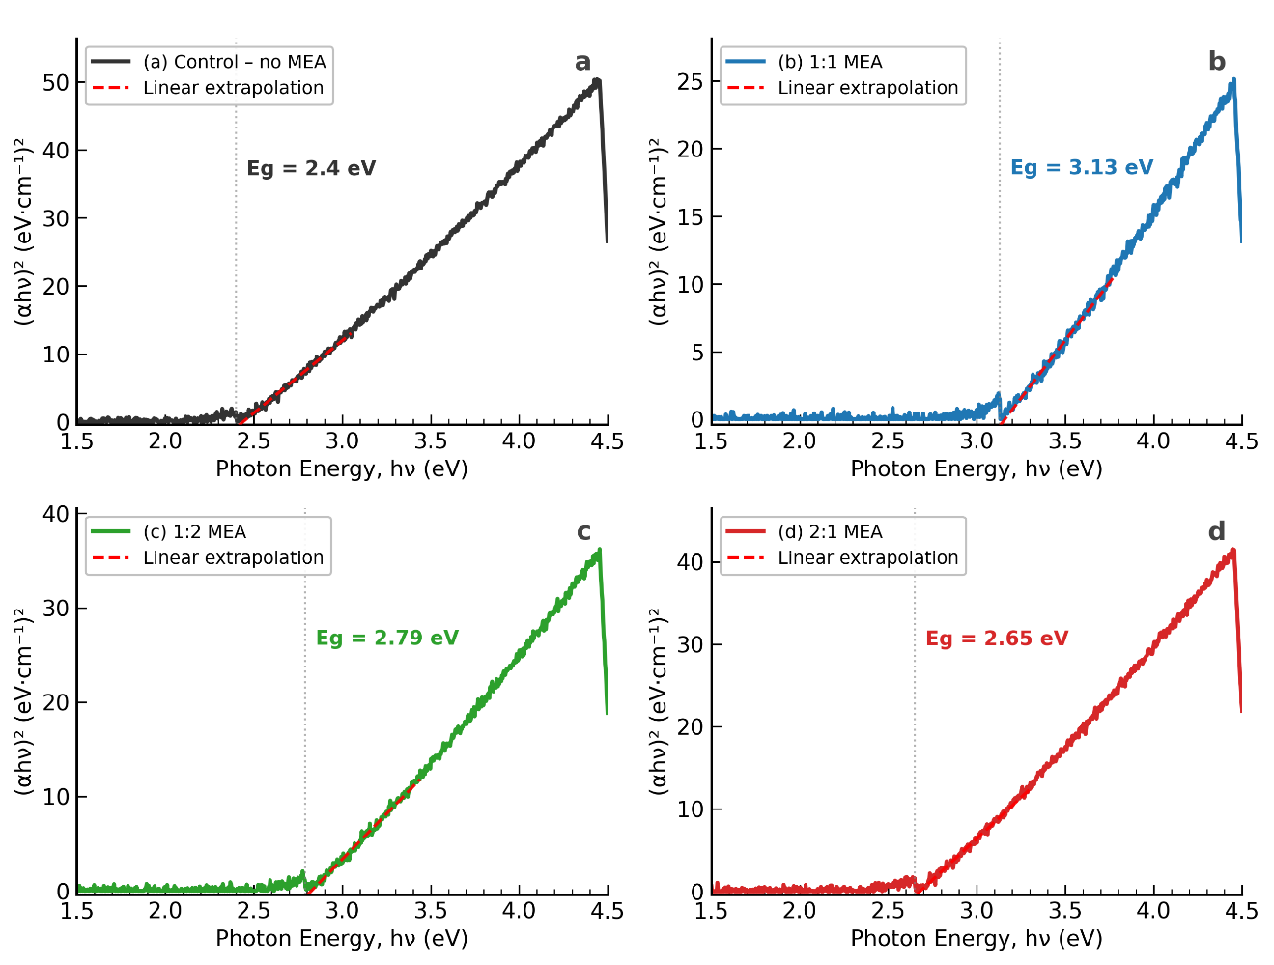

Figure 4. UV–DRS Tauc plots [(αhν)² vs. photon energy (eV)] for CuSnO₃ samples: (a) without additive (Eg = 2.4 eV), (b) 1:1 MEA (Eg = 3.13 eV), (c) 1:2 MEA (Eg = 2.79 eV), (d) 2:1 MEA (Eg = 2.65 eV). Red dashed lines indicate the linear extrapolation used for band gap determination.

The unmodified sample showed a band gap of 2.4 eV, within the reported range for CuSnO₃ [7, 8]. After MEA introduction, the band gap increased to 3.13 eV (1:1), 2.79 eV (1:2), and 2.65 eV (2:1). The elevated band gap of the 1:1 MEA sample is attributed to quantum confinement effects arising from smaller, more uniform nanoparticle domains confirmed by SEM, and to improved surface crystalline order that reduces sub-gap defect states. Analogous band gap widening with decreasing particle size has been reported in ZnO and SnO₂ nanoparticles [27]. The 1:2 and 2:1 samples yield lower band gaps because less optimal MEA concentrations produce coarser or more defective microstructures.

3.7 Photocatalytic Degradation of Methyl Orange
The photocatalytic activity of the CuSnO₃ samples was assessed by MO degradation under UV irradiation (365 nm). Control experiments confirmed that appreciable MO removal did not occur via photolysis alone (<5%), dark adsorption (<8%), or in a blank test (<1%), confirming that the observed removal is dominated by photocatalytic activity.

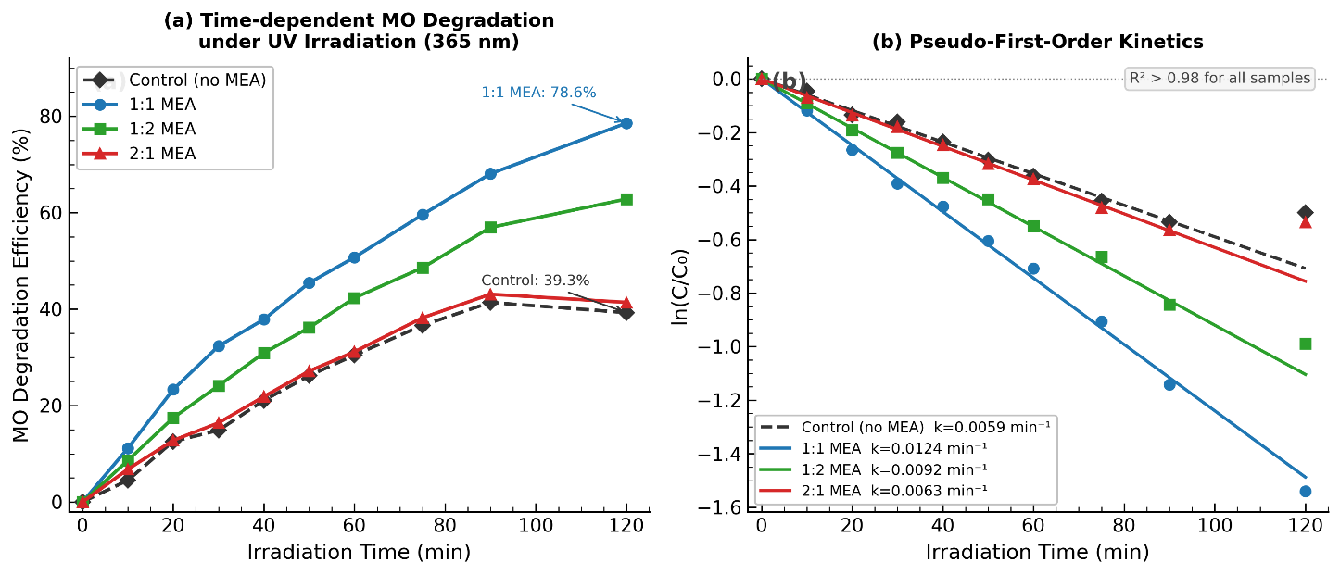

Figure 5. (a) Time-dependent MO degradation efficiency (%) under UV irradiation (365 nm) for CuSnO₃ samples with different MEA concentrations. (b) Pseudo-first-order kinetic plots [ln(C/C₀) vs. irradiation time] for all samples. Lines represent linear fits used to determine apparent rate constants (kapp).

As shown in Figure 5a, the 1:1 MEA sample achieved the highest and fastest degradation. Pseudo-first-order kinetic analysis (Figure 5b) yielded apparent rate constants of k_{app} = 0.0059, 0.0124, 0.0092, and 0.0063 min⁻¹ for the control, 1:1, 1:2, and 2:1 samples, respectively (R² > 0.98 for all; Table 2). The 1:1 MEA sample exhibited a rate constant approximately 2.1-fold higher than the unmodified sample.

Table 2. Photocatalytic degradation efficiency and pseudo-first-order kinetic parameters for MO degradation by CuSnO₃ samples.
Sample | Degradation Efficiency (%) | kapp (min⁻¹) | R²
Control (no MEA) | 39.28 | 0.0059 | 0.986
1:1 MEA | 78.56 | 0.0124 | 0.994
1:2 MEA | 62.82 | 0.0092 | 0.991
2:1 MEA | 41.40 | 0.0063 | 0.983

These kinetic differences are consistent with the structural findings. The 1:1 MEA sample combines the highest crystallinity, most uniform octahedral morphology, and best surface accessibility, all of which promote efficient charge-carrier separation and surface redox reactions. Compared with Abolhasani et al. [9], who reported ~84% methylene blue degradation with sonochemical CuSnO₃ under longer irradiation times, the present 1:1 MEA sample achieves competitive MO removal under shorter irradiation, confirming the effectiveness of MEA-directed sol–gel synthesis.

3.8 Integrated Discussion of Structure–Property–Performance Relationships
MEA's amino (–NH₂) and hydroxyl (–OH) groups coordinate with Cu²⁺ and Sn⁴⁺ ions during sol–gel precursor formation, moderating hydrolysis and condensation rates and distributing cations more evenly throughout the precursor gel [12, 13]. This yields a more ordered crystal structure and a more uniform octahedral particle morphology after calcination, as confirmed by XRD peak sharpening and SEM. The FTIR peak shifts (541.82 → 523.23 cm⁻¹) and XRF elemental distribution data confirm that MEA actively modifies local coordination chemistry and stoichiometric distribution of Cu and Sn in the final oxide.
When MEA concentration deviates from the optimum 1:1 ratio, the coordination effect becomes either insufficient (1:2 dilution) or excessive (2:1 excess). In the latter case, residual organic species, coordination crowding, and surface blockage interfere with crystallization and inhibit active-site accessibility. Although the 1:1 MEA sample exhibits the highest band gap (3.13 eV), it also shows the highest photocatalytic activity — confirming that photocatalytic efficiency in this system is governed by the combined effects of crystallinity, morphology, and surface quality rather than by simple band gap narrowing.

4. CONCLUSIONS
CuSnO₃ was successfully synthesized by the sol–gel method, and monoethanolamine was shown to be an effective chelating and structure-directing additive. The 1:1 MEA-to-metal precursor molar ratio produced the most favorable outcome: highest crystallinity (XRD), well-defined octahedral morphology (SEM), and the highest photocatalytic performance — 78.56% MO degradation with k_{app} = 0.0124 min⁻¹, approximately 2.1-fold higher than the unmodified sample. Pseudo-first-order kinetics was confirmed for all samples. XRD confirmed the CuSnO₃ cubic spinel phase, and FTIR confirmed the metal–oxygen framework. These results demonstrate that MEA concentration is a key parameter for controlling the physicochemical properties of CuSnO₃, and that the 1:1 MEA-modified CuSnO₃ is a promising photocatalyst for wastewater dye remediation.

AUTHOR CONTRIBUTIONS
Hary Sanjaya: Conceptualization, Methodology, Investigation, Data curation, Formal analysis, Writing – Original Draft, Visualization. Hermansyah Aziz: Methodology, Supervision, Formal analysis, Writing – Review & Editing. Yeni Stiadi: Resources, Validation, Writing – Review & Editing. Syukri Arief: Conceptualization, Supervision, Project administration, Writing – Review & Editing. Septian Budiman: Formal analysis, Validation, Visualization, Writing – Review & Editing. Yohandri: Supervision, Methodology, Resources, Writing – Review & Editing.

CONFLICT OF INTEREST STATEMENT
The authors declare that they have no conflict of interest.

DECLARATION OF USE OF GENERATIVE AI
Generative AI tools were used solely to assist in the design of graphical elements (icons and visual components) in the graphical abstract for presentation purposes only. AI assistance was strictly limited to this graphical task and was not used in any aspect of scientific content, including data analysis, interpretation, manuscript writing, or reference management. All scientific content is the exclusive work of the authors, who take full responsibility for the accuracy and integrity of this manuscript.

REFERENCES
[1] Sarkar A., Das B., Selvaraj M. and Basumatary S., Development of hybrid MMT/g-C₃N₄/Ca–Ni–Al layered triple hydroxide composite for highly effective removal of cationic and anionic dyes. Journal of the Indian Chemical Society, 2025; 102(issue): 102267. DOI 10.1016/j.jics.2025.102267. Issue number is missing.
[2] You J., Zhang L., He L. and Zhang B., Photocatalytic degradation of methyl orange on ZnO–TiO₂/SO₄²⁻ heterojunction composites. Opt Mater (Amst), 2022; 131: 112737. DOI 10.1016/j.optmat.2022.112737.
- The journal's name should be written as an italicized full name.
[3] Basumatary F., Sarkar A., Mushahary N., Das B., Saikia P., Selvaraj M., et al., Graphitic carbon nitride composites as versatile materials for adsorption and photocatalytic degradation of pollutants…………. Process Safety and Environmental Protection, 2024; 191(Part B): 2416–2468. DOI 10.1016/j.psep.2024.09.077. There was a discrepancy in the title compared to the original.
[4] Abdeta A.B., Wu Q., Kuo D.-H., Li P., Zhang H., Zhang J., et al., Activated carbon-supported AgMoOS bimetallic oxysulfide as a catalyst for photocatalytic hydrogen evolution and pollutants reduction. J Alloys Compd, 2022; 913: 165287. DOI 10.1016/j.jallcom.2022.165287.
- The journal's name should be written as an italicized full name.
[5] Wang J., Li Z. and Gu Z., A comprehensive review of template-synthesized multi-component nanowires: From interfacial design to sensing and actuation applications. Sensors and Actuators Reports, 2021; 3: 100029. DOI 10.1016/j.snr.2021.100029.
[6] Ghamarpoor R., Fallah A. and Jamshidi M., A review of synthesis methods, modifications, and mechanisms of ZnO/TiO₂-based photocatalysts for photodegradation of contaminants. ACS Omega, 2024; 9(issue): 25457–25492. DOI 10.1021/acsomega.3c08717. Issue number is missing.
[7] He H., Liao A., Guo W., Luo W., Zhou Y. and Zou Z., State-of-the-art progress in the use of ternary metal oxides as photoelectrode materials for water splitting and organic synthesis. Nano Today, 2019; 28: 100763. DOI 10.1016/j.nantod.2019.100763.
[8] Singh J. and Uma S., Synthesis, characterization, and optical properties of perovskite-type CuSnO₃. Ceramics International, 2018; 44(2): 1843–1849. DOI 10.1016/j.ceramint.2017.10.119. The author list and Title didn’t match with DOI.
[9] Abolhasani M., Boroujerdnia M. and Cheraghizade M., Sonochemical synthesis of CuSnO₃ NPs as a photocatalyst for efficient degradation of MB and environmental remediation. Physica B Condens Matter, 2025; 717: 417837. DOI 10.1016/j.physb.2025.417837. - The journal's name should be written as an italicized full name.
[10] Chang C., Rad S., Gan L., Li Z., Dai J. and Shahab A., Review of the sol–gel method in preparing nano TiO₂ for advanced oxidation process. Nanotechnol Rev, 2023; 12(issue): Article id. DOI 10.1515/ntrev-2023-0150. - The journal's name should be written as an italicized full name, issue number and article id are missing.
[11] Liu N., Ouyang D., Cai Y. and Li Y., Heterostructured Fe₂O₃/BiVO₄ nano-photocatalyst for the reduction of nitroarenes into amines. Ceram Int, 2020; 46(issue): 24534–24543. DOI 10.1016/j.ceramint.2020.06.240. - The journal's name should be written as an italicized full name, issue number is missing.
[12] Gómez-Núñez A., Alonso-Gil S., López C., Roura P. and Vilà A., Role of ethanolamine on the stability of a sol–gel ZnO ink. The Journal of Physical Chemistry C, 2017; 121(issue): 23839–23846. DOI 10.1021/acs.jpcc.7b09935. Issue number is missing.
[13] Tumbul A., Effect of monoethanolamine content on the crystallinity of ZnO thin films. Süleyman Demirel University Faculty of Arts and Science Journal of Science, 2019; 14(issue): 155–164. DOI 10.29233/sdufeffd.513412. Issue number is missing.
[14] Florence S., Enhanced photocatalytic degradation of selected contaminant dyes from textile sewage discharge using Citrus limetta mediated ZnO nanopellets. Chiang Mai Journal of Science, 2024; 51(6): e2024106. DOI 10.12982/CMJS.2024.106.
[15] Phatai P., Kamonwannasit S., Siri-udom S., Futalan C.M., Khemthong P., Youngjan S., et al., Increased antibacterial activity of zinc-silver doped hydroxyapatite synthesized via ultrasonic-sol-gel technique. Chiang Mai Journal of Science, 2024; 51(3): e2024044. DOI 10.12982/CMJS.2024.044.
[16] Xu X., Yang Y., Miao Y., Liu K., Chen Y. and Yue S., Cu₂O(ClO₄)₂/TiO₂ dandelion-shaped nanospheres with photocatalytic antibacterial activity. Chiang Mai Journal of Science, 2022; 49(2): 434-445. DOI 10.12982/CMJS.2022.021.
[17] Hermawan A., Asakura Y., Inada M. and Yin S., A facile method for preparation of uniformly decorated-spherical SnO₂ by CuO nanoparticles for highly responsive toluene detection………………... J Mater Sci Technol, 2020; 51: 119–129. DOI 10.1016/j.jmst.2020.02.041. There was a discrepancy in the title compared to the original and the journal's name should be written as an italicized full name.
[18] Rahimi A. and Kazeminezhad I., Amorphous copper stannate/reduced graphene oxide composite as an efficient photoanode for photoelectrochemical water splitting. Opt Mater (Amst), 2025; 165: 117107. DOI 10.1016/j.optmat.2025.117107. - The journal's name should be written as an italicized full name.
[19] Ma J., Zhang Z., Mentbayeva A., Yuan G., Wang B., Wang H., et al., Enhanced electrochemical performance of hollow heterostructured carbon encapsulated zinc metastanate microcube composite………………... Electrochim Acta, 2019; 312: 31–44. DOI 10.1016/j.electacta.2019.04.167. There was a discrepancy in the title compared to the original and the journal's name should be written as an italicized full name.
[20] Raina P., Nike T., Kaushal D., Chauhan V., Shandilya P. and Kumar M., A review on stannate perovskites-based heterojunctions and their applications………………... Mater Sci Semicond Process, 2025; 188: 109224. DOI 10.1016/j.mssp.2024.109224. There was a discrepancy in the title compared to the original and the journal's name should be written as an italicized full name.
[21] Fayomi O.S.I., Ayuba S.U. and Omotosho O.A., Understanding the nanomechanical performance of super stable metal-atomic distribution of Cu₄₅₊Al₂₅₊Zn₅₊Sn₂₅ high entropy alloy……………….... J Alloys Compd, 2024; 978: 173539. DOI 10.1016/j.jallcom.2024.173539. There was a discrepancy in the title compared to the original and the journal's name should be written as an italicized full name.
[22] Stambouli I., Zerouali M., Daïra R., Bouras D., El-Hiti G.A., Grigorian S., et al., Enhancement of tin-doping on the structural and optical properties of copper oxide thin films………………..... Ceram Int, 2025; 51(issue): 17689–17703. DOI 10.1016/j.ceramint.2025.01.540. There was a discrepancy in the title compared to the original, the journal's name should be written as an italicized full name and Issue number is missing.
[23] Sun H., Boke Abdeta A., Kuo D.-H., Wu Q., Guo Y., Ahmed Zelekew O., et al., Activated carbon supported CuSnOS catalyst for catalytic reduction of pollutants………………... J Mol Liq, 2021; 334: 116079. DOI 10.1016/j.molliq.2021.116079. There was a discrepancy in the title compared to the original and the journal's name should be written as an italicized full name.
[24] Meng Y., Ding J., Liu Y., Hu G., Feng Y., Wu Y., et al., Advancements in amorphous oxides for electrocatalytic carbon dioxide reduction. Materials Today Catalysis, 2024; 7: 100065. DOI 10.1016/j.mtcata.2024.100065.
[25] Liang H., Li Y., Miao Z., Wang X., Sun Y., Zhang Y., et al., Research progress on metal-based catalysts for CO₂ electroreduction. J Environ Chem Eng, 2025; 13(issue): 116547. DOI 10.1016/j.jece.2025.116547. There was a discrepancy in the title compared to the original, the journal's name should be written as an italicized full name and Issue number is missing.
[26] Rehman B., Khan S.A., Nasar A., Shahjahan., Alimuddin. and Ahamad Z., Synergistic Fe-Sn-Ni ternary metal oxide nanocomposite for Congo red adsorption:……………………….. Next Materials, 2026; 10: 101502. DOI 10.1016/j.nxmate.2025.101502. There was a discrepancy in the title compared to the original.
[27] Lv J., Gong W., Huang K., Zhu J., Meng F., Song X., et al., Effect of annealing temperature on photocatalytic activity of ZnO thin films prepared by sol–gel method. Superlattices Microstruct, 2011; 50(issue): 98–106. DOI 10.1016/j.spmi.2011.05.003. The journal's name should be written as an italicized full name and Issue number is missing.
[28] Liu Y., Xu X., Sun X., Li W. and Duan J., Recent research progress of photoelectrocatalysis technology in ……removal of organic pollutants………….... Journal of Water Process Engineering, 2025; 75: 107911. DOI 10.1016/j.jwpe.2025.107911. There was a discrepancy in the title compared to the original.
[29] Chen X., Shang Y., Li K., Lv Y. and Pan X., Photothermal activation in amorphous Cu-Fc MOF nanoarchitectures for ultrafast catalytic reduction of …………... organic pollutants………….... Appl Surf Sci, 2025; 706: 163546. DOI 10.1016/j.apsusc.2025.163546. There was a discrepancy in the title compared to the original and the journal's name should be written as an italicized full name.
[30] Zhang P., Wang H., Lai Y., Xu Y., Chen L., Wu Q., et al., Synergistic Co/S co-doped CeO₂ sulfur-oxide catalyst for efficient catalytic reduction of…………... pollutants………….... Journal of Water Process Engineering, 2024; 58: 104820. DOI 10.1016/j.jwpe.2024.104820. There was a discrepancy in the title compared to the original.

